Microcomputer Design

Chandler Griscom

01Jan2016

Design Report #3

- Time – 29.5 Hours total
  - Week 3 (Wed-Sun) – 20 Hours
  - Week 4 (Mon-Wed) – 9.5 Hours

- Accomplishments
  - Completed schematic and emailed it to Dr. Kim
  - Verified components, made some symbol corrections
  - Finished PCB
  - Ordered PCB!

- Planned Work
  - Take a break
  - Start looking into CPLD programming

- Project Completion
  - Hardware: 90%
  - Software: 2%
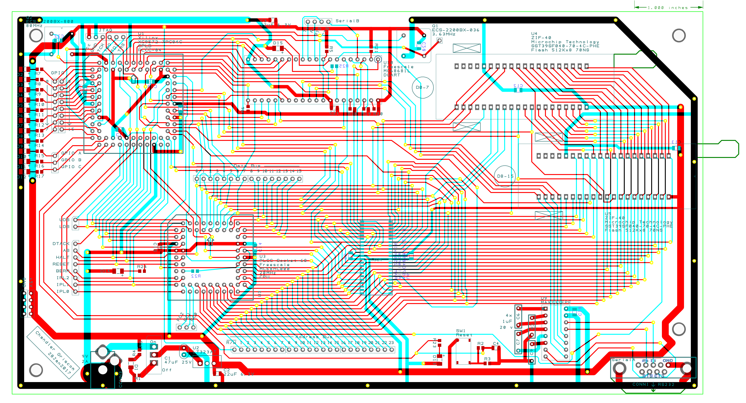

(PCB Progress 30Jan2017)

